EXPERIMENT :01
Aim
To simulate and analyze TEM, TE, and TM propagation modes in microwave transmission structures using MATLAB and study their electromagnetic field distributions and propagation characteristics.
Objectives
1. To understand the basic concepts of TEM, TE, and TM propagation modes.
2. To simulate electric and magnetic field distributions using MATLAB.
3. To calculate cutoff frequency, propagation constant, and guide wavelength.
4. To compare the propagation characteristics of TEM, TE, and TM modes.
5. To visualize and analyze the simulation results using graphs and 3D plots.
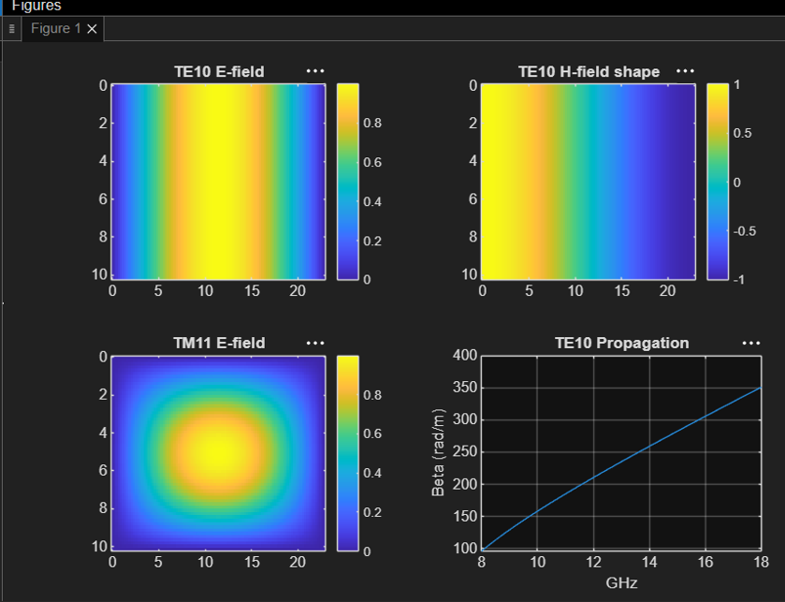
OUTPUT:

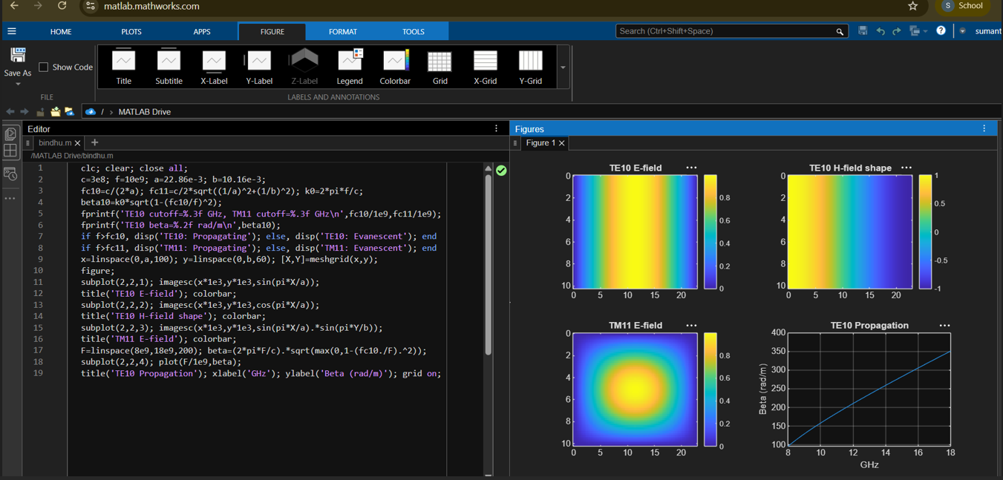

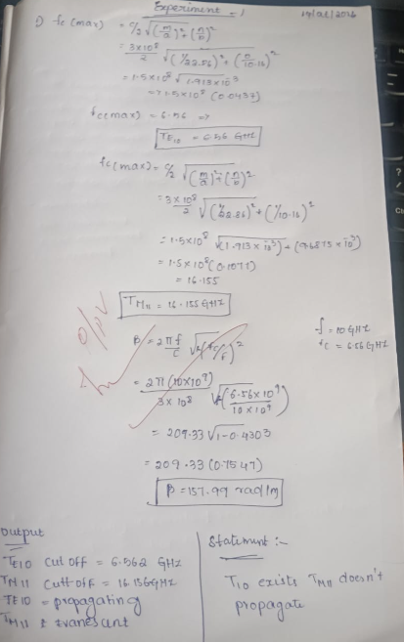
RESULT:
The TEM, TE, and TM propagation modes were successfully simulated using MATLAB, and their electromagnetic field distributions and propagation characteristics were analyzed and compared.

